Project Design Phase
Solution Architecture

Date | 13 July 2026
Team ID | -
Project Name | Book Store
Maximum Marks | 4 Marks

Solution Architecture
The Book Store Solution Architecture is designed to bridge the gap between customer requirements and technology by providing a secure, scalable, and efficient online platform for buying and managing books. The system uses the MERN Stack (MongoDB, Express.js, React.js, and Node.js) to deliver a seamless experience for both customers and administrators.
Its goals are to:
- Provide an efficient online platform for users to search, browse, and purchase books.
- Describe the overall structure, modules, and workflow of the Book Store system for project stakeholders.
- Define the key features such as user registration, login, book management, shopping cart, order management, and secure payment integration.
- Ensure secure, scalable, and reliable management of books, customers, and orders through a well-defined system architecture.
- Support future enhancements such as e-books, AI-based book recommendations, mobile applications, and multiple payment options.
- Provide clear technical specifications for designing, developing, deploying, and maintaining the Online Book Store application.

Example - Solution Architecture Diagram:
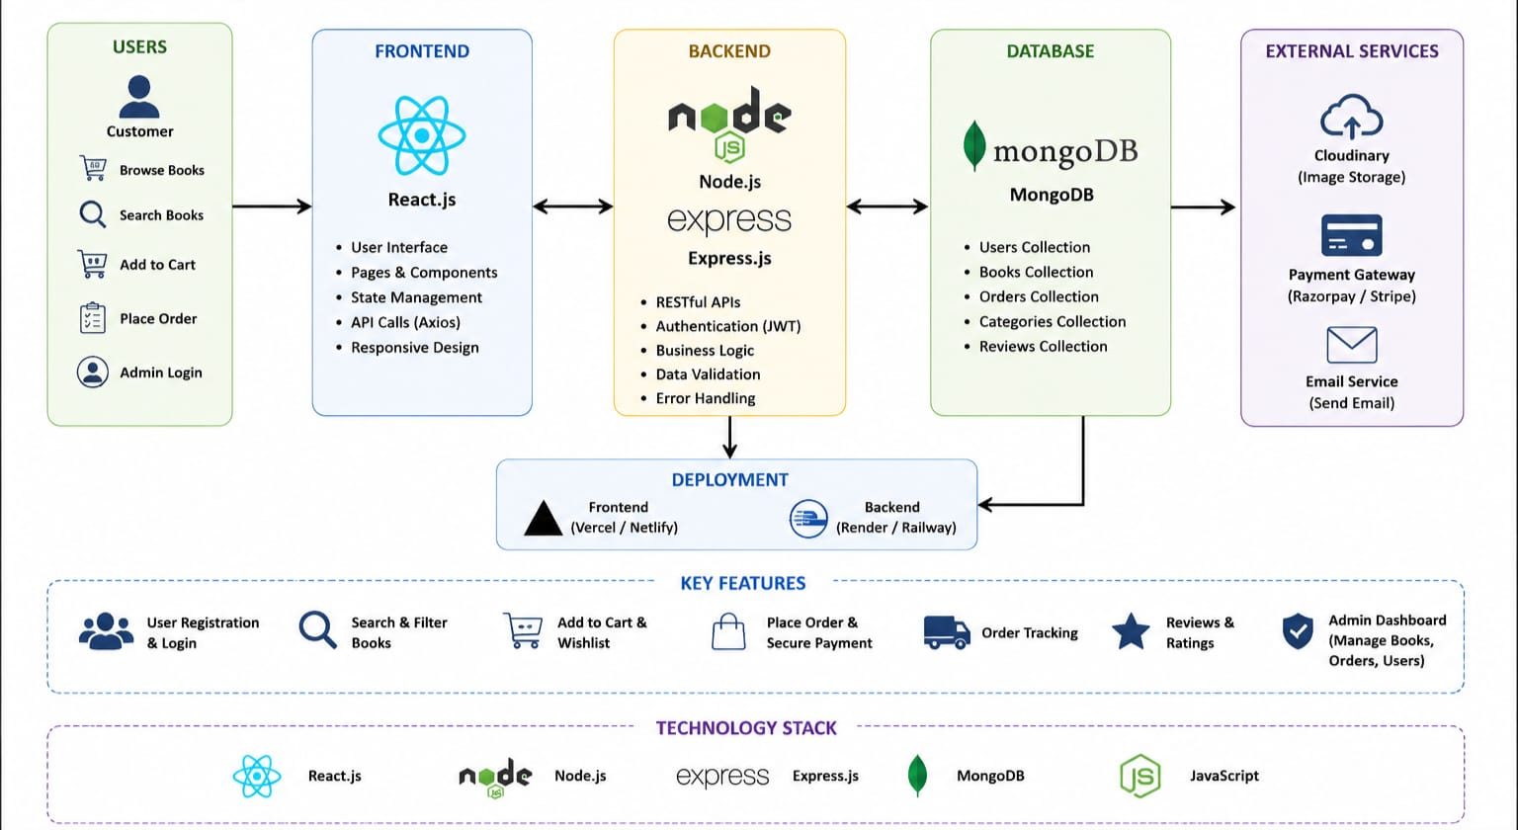
Figure 1: MERN Stack Based Online Book Store Solution Architecture
Reference: https://aws.amazon.com/blogs/industries/voice-applications-in-clinical-research-powered-by-ai-on-aws-part-1-architecture-and-design-considerations/

